OBSERVATIONS

* If you use an xml first save it as csv
* For the predictions when you load the dataset you should import the csv not the xml
* The schema should be labeled

First Test using a labeled set:

Whats_app(08 May 2021).xml

Import the file and save as CSV

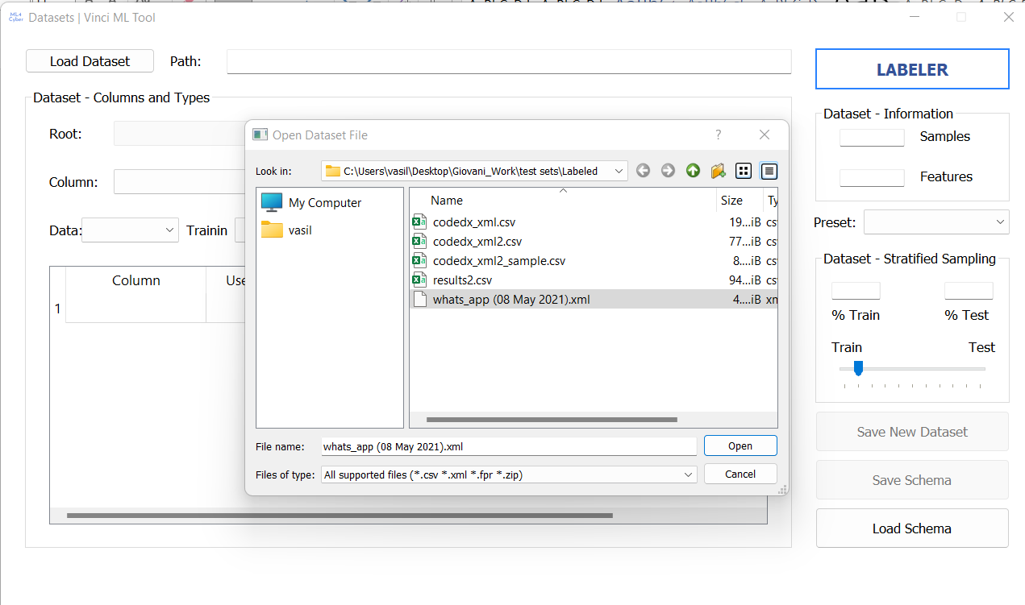

Make sure you select the Status as column value and for Type output then save the new dataset ( do not add the column since this file already contains a status column)

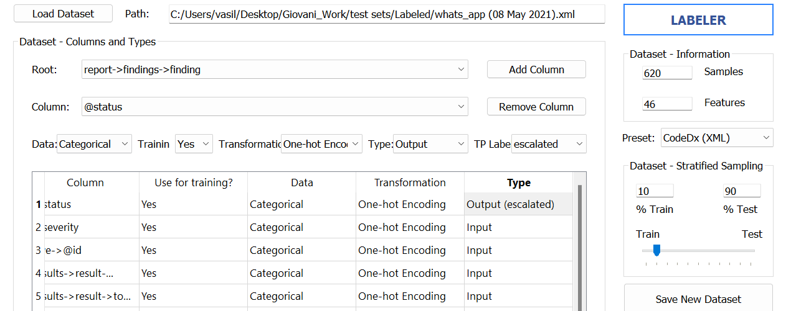

Close the window load it again and pick the dataset you just created, go to the labeler since this is already a labeled set just divide , make sure the sampling technique is stratified and save the dataset.

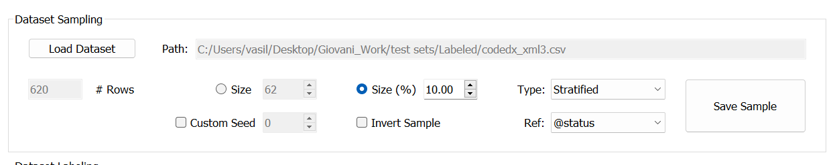

Load the sample dataset and make sure you choose code dx csv and then save the schema

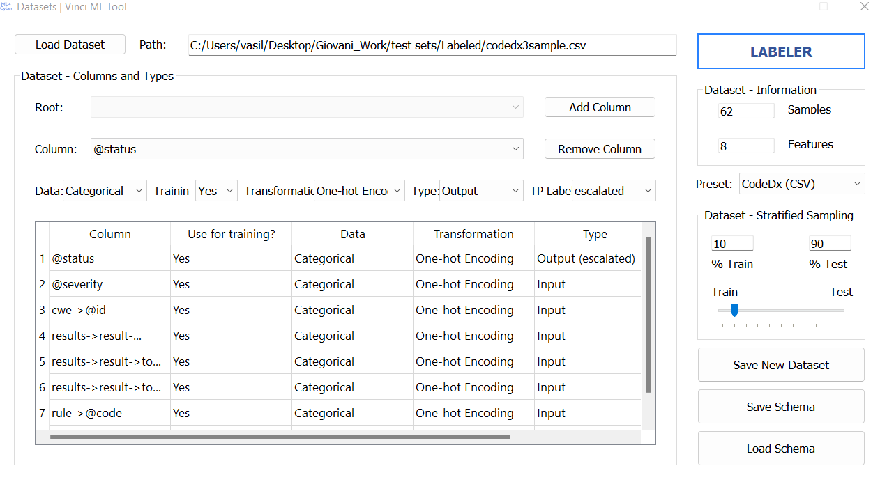

Model Training

Load the schema and select train now than save the model

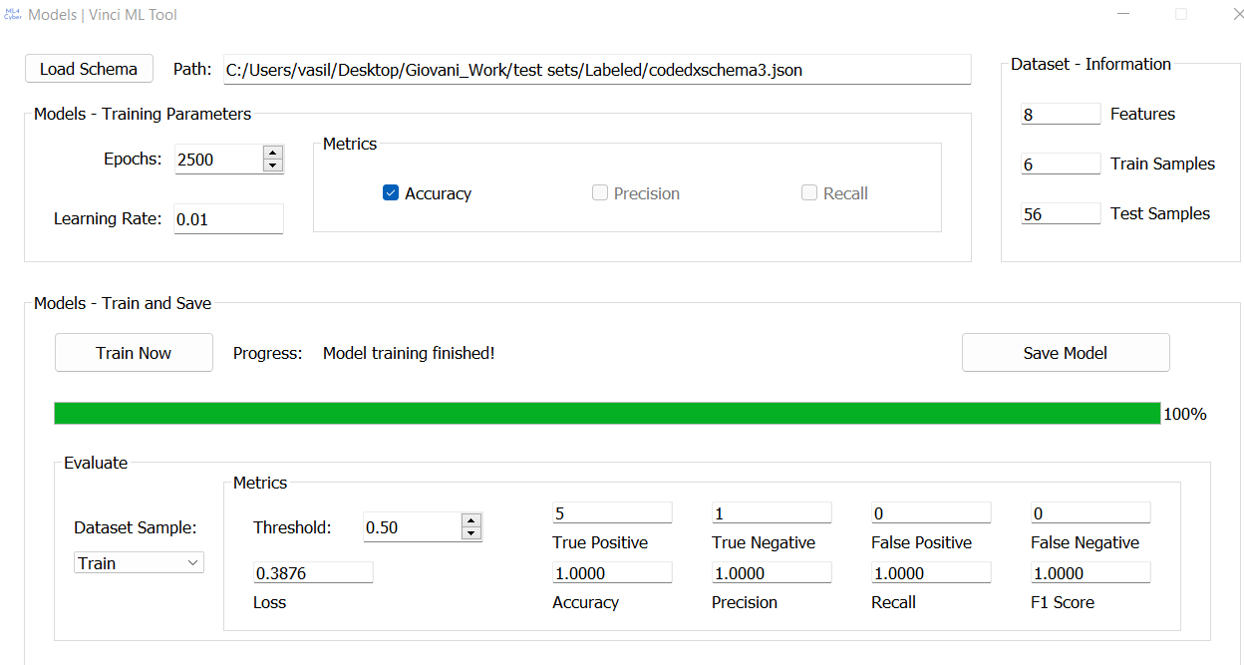

Predictions

Load the dataset you created the schema and the model, select predict and then save your predictions